Fournisseur | Ref Farnell | Ref Constructeur | Désignation | Photo
FARNELL | 2191848 | P1K0.0805.1FC.B.S | PT100 | 
FARNELL |  |  | PT100 traversant
FARNELL | 2191841 | P0K1.202.3FW.B.007 | PT1000 | 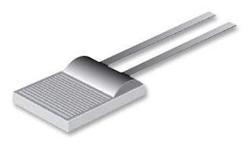
FARNELL | 1206905 | INA155UG4 | Ampli d’instrumentation | 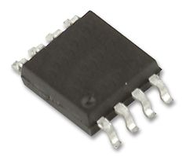
FARNELL | 1097400 | INA126PA.. | Ampli d’instrumentation | 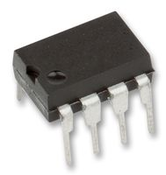
FARNELL | 1212408 | INA126EA
FARNELL | 2117790 | CPF0201D1K24E1 | 1k24 0,5% | 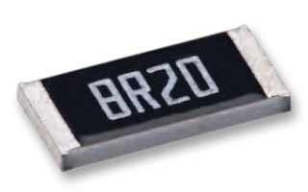

Platinum Properties
The function of the Pt temperature sensor or heating element is based on the temperature dependence of the electrical resistance of the platinum metal. The relationship can be described by the following characteristic polynomial:
R_{T} = R_{o} (1+αt+βt²)
R_{T} = Measured resistance
R_{o} = Nominal resistance at 0°C
The constants are defined in the international standards for Pt temperature sensors.
α = 3.9083 x 10⁻³ °C⁻¹
β = -5.775 x 10⁻⁷ °C²
β is so small that for most applications a linear relationship between R_{T} and the temperature can be assumed.
Pt temperature sensors with high nominal resistances have a higher sensitivity than those with lower nominal resistances, because the slope of the characteristic is directly proportional to R_{o}.

Measured currents and self-heating
Current supply for the platinum thin-film sensor. The resulting temperature measuring error is given by:
Δt = P*S
with P, the power loss = I²R
and S , the self-heating coefficient in K/mW.
The self-heating coefficients are specified in the datasheets for the individual products. Self-heating is dependent on thermal contact between the platinum thin-film sensor and the surrounding medium. If the heat transfer to the surrounding environment is maximized, higher measured currents can be used. Platinum thin-film sensors set no lower limits for measured currents. They depend, to a great extent, on the application.
We recommend:
100 Ohm: max. 1 mA
500 Ohm: max. 0,7 mA
1000 Ohm: max. 0,3 mA
2000 Ohm: max. 0,25 mA
10000 Ohm: max. 0,1 mA

Thermal response times
The thermal response time is the time required by a platinum thin-film sensor to react to a step-by-step temperature change with a change in resistance, which corresponds to a certain percentage share of the temperature change. DIN EN 60751 recommends the use of times for a 50 % and 90 % change, t0.5 and t0.9 are indicated in the datasheets for water and air flows of 0.4 or 2.0 m/s. Conversion to other media and speeds can be carried out with the aid of the VDI/VDE 3522 manual.
High temperature capability, excellent chemical resistance, biological inertness and long-term electrical stability make platinum a natural choice as the base material for temperature measurement resistance elements, heaters or electrodes.
Due to the special properties of platinum, Pt measurement resistors with 1,000, 2,000 or 10,000 ohms provide a range of advantages compared to competing sensors such as semiconductor sensors (KTY®) or thermistors (NTC):
- high precision
- low drift
- long service life
- nearly linear characteristic
- standardised characteristic line assures sensor interchangeability
- fast response time
- high resistance to thermal shock
- wide temperature application range from -196°C to +1,000°C.

Thin Film Platinum RTD Platinum on ceramic substrate | NTC Thermistor metal oxide | KTY® Silicon, Barium Titanate | Thermo- couples
Operating temperature range from -196°C bis 1000°C | Operating temperature range from -100°C to 300°C, with special types to 500 °C | Operating temperature range from -55°C to +300°C | Operating temperature range from -200°C to +1800°C, depending on type
Characteristic nearly linear and standardized to DIN EN 60751 | Non-linear characteristic curve No international standard for curves | Characteristic more linear than NTC thermistors over the operating temperature range; linearity deviation at least 0.6°C (with optimum linearization) | International standardization of Thermocouple types
Temperature measurement range standard: -70°C to +500°C high: -40°C to 1000°C | Temperature measurement range dependent upon type; typical range 200 K | Temperature measurement range 200 K; standard: -55°C to +150°C | Temperature measurement range -40°C to +1700°C (range depends on type), need of cold-junction compensation, e.g. with TF-PRTD element
Nominal resistance drift: 0.04% after 1000 h at +500°C | Nominal resistance drift: 0.35% after 100h at 150°C | Nominal resistance drift: 0.45% after 1250 h at 150°C | Dependent upon thermometer design
Accuracy to DIN EN 60751, Class B: ± 0.21% at +100°C ± 0.33% at +500 °C | Typical accuracies ± 1% resistance, +/-0.2°C over narrow temperature ranges | Average accuracy ± 5% resistance highest accuracy: ±0.5% | Accuracy of Tolerance Class 2, depending on type: 2.5°C or 0.0075 x I t I Cabling with compensation cables
Signal sensitivity consistent over the entire operating temperature range; for example, > 4 ohms/Deg K for Pt1000 | High signal sensitivity, but only for certain temperature intervals; larger resistance change per Deg. K than Pt RTD or KTY | High signal sensitivity, approx. 15 ohm/K | SSensitivity ranges from µV/Deg K to mV/Deg K, depending upon thermocouple type
Models: Basic element with connecting wires or strips, SMD types, SOT223 and TO92 cases | Models: Epoxy or glass encapsulation; diode (DO-35) package, SMD models, many variants; for automatic assembly | Models: Glass case, SMD and diode (DO-35) package components | Mineral-insulated Thermocouples, bare Thermocouple wires
